**Online Car Rental System**



**BTech/III Year CSE/V Semester**

**15CSE302/Database Management Systems**

**Project Review -3**

|  |  |
| --- | --- |
| Roll no | Name |
| CB.EN.U4CSE18224 | **G. Hema Chowdary** |
| CB.EN.U4CSE18240 | **N. Haswanth Rajesh** |
| CB.EN.U4CSE18243 | **P. Yaswanth Ram** |
| CB.EN.U4CSE18270 | **T. Bhavana Reddy** |
|  |  |

**Amrita school of engineering, Coimbatore**

**Department of computer science and engineering**

**2020-2021 Odd semester**

**Table of contents**

**Chapter Title**

Chapter 1 Introduction

Chapter 2 Logical database design ER diagram

Chapter 3 ER to relational schema Mapping

Chapter 4 Normalization

Chapter 5 Creation of tables

Chapter 6 User Interface Design

Chapter 7 Connectivity code

**Chapter 1: Introduction**

The purpose of this project is to develop a system design for online car rental system. The car rental system provides a list of all available cars. Admin can add a car, manage booking car and rent and also view feedback and enquiry. User can view information of available car, booking car, easily get the car on rent and also give feedback and can do enquiry. In enquiry the user can directly contact the admin and enquire about the cars, etc. Car details include car-number, car-name, fuel-type, availability, seating-capacity, color, cost_per_km. Rent details include the time period and cost for the entire time period that the user rents the car. Payment details includes card details and the rent details and the caution deposit which will be refunded at the return of the car. Feedback will be given by the user while returning the car. Here payment can be done through online or manually.

**Abstract:**

Our Aim is to design and create a data management System for an online car rental system. The online car rental system is user friendly. Thus, the users will find easy to work on it. It saves time to the user. User should login to the particular portal by giving username and password. Then the user should fill their details, and they should choose the vehicle based on their requirements. And it takes to the transaction page where the transaction can be done through online or manual.

# Chapter 2: Logical database design ER Diagram

# 

## **Entities:**

1. Admin
2. User
3. Car details
4. Payment details
5. Rent details
6. Feed back
7. Enquiry

**Attributes:**

* Admin: Admin id,Username, Password, Phone number, Email id
* User: Cust id, name, email id, DOB, Gender, phone no, address, password
* Car details: Car id, Car no, Car name, Capacity, Availability, Cost/km, Fuel type
* Payment details: Payment id, card details(card no, expiry date, cvv), Car name, Custid, Advance amount, Car no, Tax amount, Total amount
* Rent details: Car id, Cust id,Total no of days, Car name, Cost/km, Country, Location, City, Car no, Start date, End date
* Feedback: Feedback no, Cust id, Email id, Phone num, Rating
* Enquiry: Enquiry id, Cust id, Questions, phone no

**Relationships:**

* Admin - answers - enquiry :[ Binary relationship]
* Admin – adds – car details: [ Binary relationship]
* Admin – checks – Feedback: [ Binary relationship]
* Users – gives – Feedback: [ Binary relationship]
* Users – takes car for rent – rent details: [ Binary relationship]
* Users – will do – Payment details: [ Binary relationship]
* Users – asks – Enquiry: [ Binary relationship]

# 

# Chapter 3 ER to Relational Schema Mapping

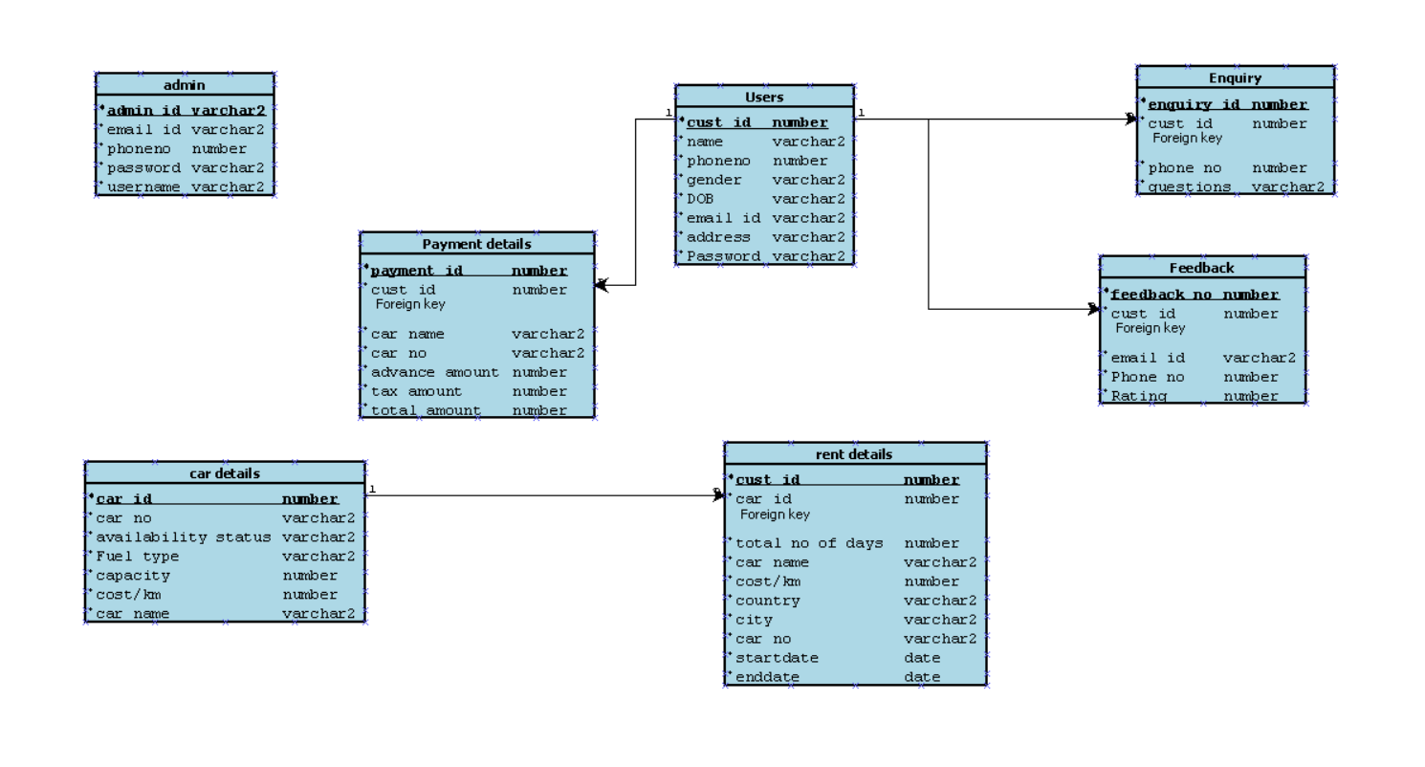

**Chapter 4: User Interface Screens**

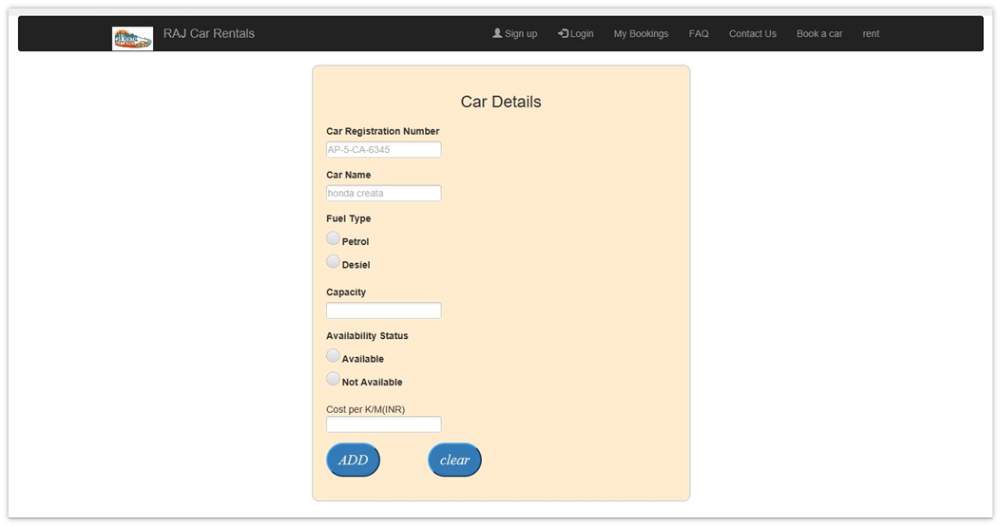

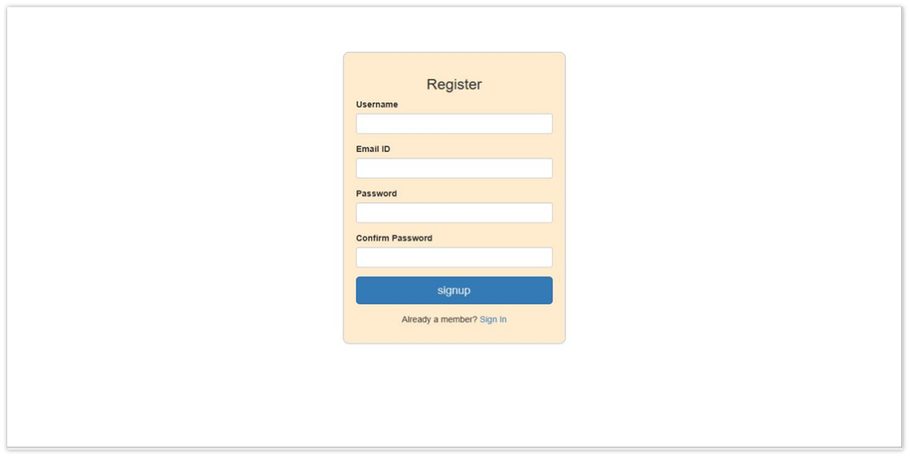

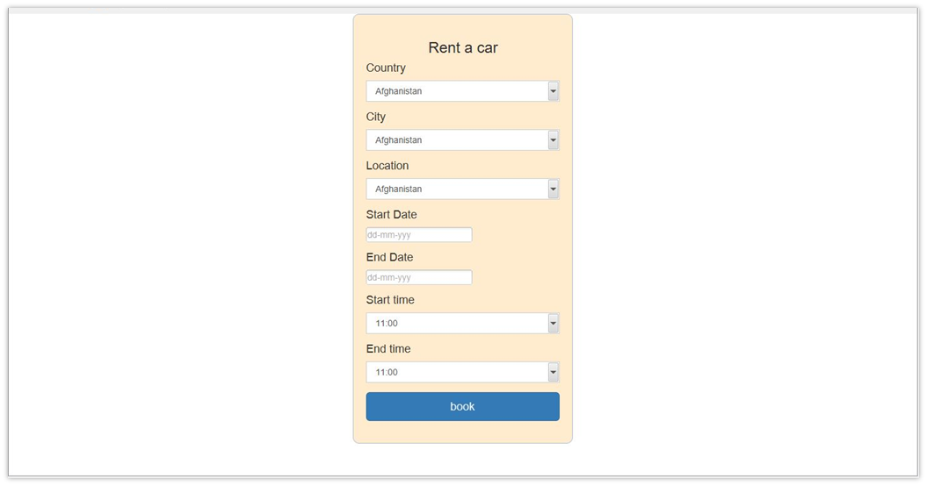

**Chapter 4: Normalization**

**Initial schema with all attributes:**

**Online_car_rent**(adminid,custid,a_name,a_password,a_phoneno,a_emailid,u_name,u _emailid,dob,gender,u_phoneno,address,u_password,carid,carno,carname,capacity,av ailability,cost/day,fueltype,carimage,questions,rating,rent_id,country,city,startdate,endda te,paymentid,carddetails,advanceamt,taxamt)

**Functional dependencies:**

●**adminid -->**a_name,a_password,a_phoneno,a_emailid,advanceamt,taxamt,carid

●**custid-->**u_name,u_emailid,u_phoneno,dob,gender,address,u_password,rent_id, paymentid,rating,questions

●**carid -->**carno,carname,capacity,availability,fueltype,cost/day,carimage

●**rent_id** **-->**carid,country,city,startdate,enddate

●**paymentid - ->**carddetails,advanceamt,taxamt

**Initial functional dependency diagram:**

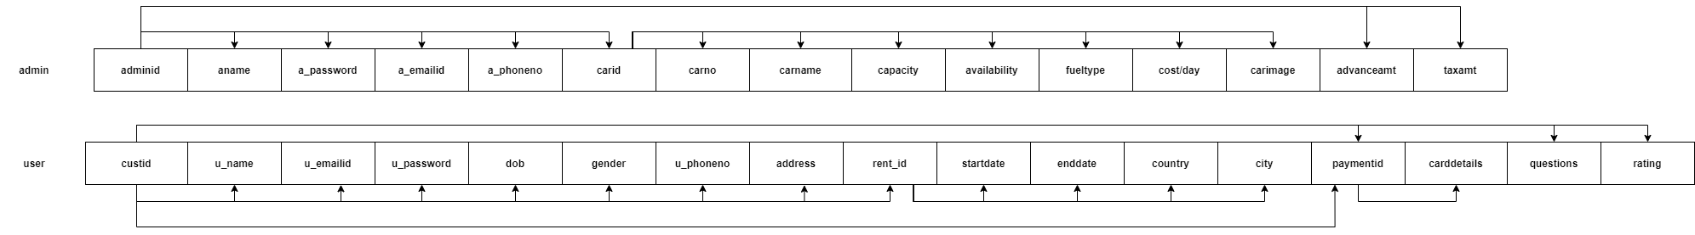

**FD Closure:**

1. adminid->a_name,a_password,a_phoneno,a_emailid,advanceamt,

taxamt,carid, carno,carname,pic,capacity,availability

1. custid->u_name,u_emailid,dob,gender,address,u_password,

country,city,carddetails,startdate,enddate,r_id,paymentid,rating,questions

1. carid ->carno,carname,pic,capacity,availability,fueltype,cost/day
2. r_id ->carid,carno,carname,country,city,startdate,enddate
3. paymentid ->carddetails,advanceamt,taxamt
4. adminid+->fueltype,cost/day(transitive rule)
5. custid+->advanceamt,taxamt(transitive rule)
6. custid+->carid,carno,carname(transitive rule)

**Attribute closure:**

**1.adminid**

● adminid={adminid,a_name,a_password,a_phoneno,a_emailid,advanceamt,taxa mt,carid} With transitivity rule,

carid->carno,carname,capacity,availability,fueltype,cost/day,carimage

adminid={adminid,a_name,a_password,a_phoneno,a_emailid,advanceamt,taxa mt,carid,carno,carname,capacity,availability,fueltype,cost/day,carimage}

**2.custid**

●custid={custid,u_name,u_password,u_emailid,dob,gender,address,rating,questions, rent_id,paymentid}

With transitivity rule,

rent_id -> country,city,startdate,enddate

paymentid -> carddetails,advanceamt,taxamt

custid={custid,u_name,u_password,u_emailid,dob,gender,address,rating,questio ns,rent_id,paymentid,country,city,startdate,enddate,carddetails,advanceamt,taxa mt}

**3.carid**

● carid={carid,carno,carname,capacity,availability,fueltype,cost/day,carimage}

**4.rent_id**

● rent_id={rent_id,carid,country,city,startdate,enddate}

With transitivity rule,

carid -> carno,carname,capacity,availability,fueltype,cost/day,carimage

rent_id={rent_id,carid,country,city,startdate,enddate, carno,carname,capacity,availability,fueltype,cost/day,carimage}

**5.paymentid**

● paymentid={carddetails,advanceamt,taxamt}

**Superkey:** Since a single attribute does not determine all other attributes, composite superkey exists(adminid,custid)

**Canonical Cover:**

There are no extraneous attributes

● adminid -> a_name

● adminid -> a_password

● adminid -> a_phoneno

● adminid -> a_emailid

● adminid -> advanceamt

● adminid -> taxamt

● adminid -> carid

● custid -> u_name

● custid -> u_password

● custid -> u_emailid

● custid -> u_phoneno

● custid -> dob

● custid -> gender

● custid -> address

● custid -> rating

● custid -> feedback

● custid -> rent_id

● custid -> paymentid

● carid -> carno

● carid -> carname

● carid -> capacity

● carid -> availability

● carid -> fueltype

● carid -> cost/day

● rent_id -> carid

● rent_id -> country

● rent_id -> city

● rent_id -> startdate

● rent_id -> enddate

● paymentid -> carddetails

● paymentid -> advanceamt

● paymentid -> taxamt

**Checking for 1st Normal Form:**

➔ Primary key exists:(adminid,custid)(composite primary key)

➔ There exists no repeating group of columns.

➔ Some attributes are non-atomic(a_phoneno,u_phoneno)are multivalued attributes.

Since there are attributes that are not atomic,the relation is not in 1st normal form.To convert it into 1st normal form, combining the phone number into composite primary key and the multiple values can be added as separate rows.

**Schema in 1st normal form:**

Online_car_rent(adminid,custid,u_phoneno,a_phoneno,a_name,a_password,a_emaili d,u_name,u_emailid,dob,gender,address,u_password,carid,carno,carname,capacity,av ailability,cost/day,fueltype,carimage,questions,rating,rent_id,country,city,startdate,endda te,paymentid,carddetails,advanceamt,taxamt)

**Anomalies:**

1.Insert: New car details cannot be added without adding admin and rent details cannot be added without user.

2.Delete: If user details are deleted then the particular rent details will be deleted.

3.There is no update anomaly.

**Checking for 2nd normal form:**

➔ It is in 1st normal form

➔ Partial dependencies exists

**adminid**->a_name,a_password,a_emailid,advanceamt,taxamt,carid, carno,carname,capacity,availability,cost/day,carimage

**custid**->u_name,u_emailid,dob,gender,address,u_password,country,city, carddetails,startdate,enddate,rent_id,paymentid,rating,questions

**u_phoneno and a_phoneno** àdoes not determine non-prime attribute Part of the composite primary key determines non-prime attribute, so the partial dependencies exist here and therefore it is not in 2nd normal form. To convert it into 2nd normal form it can be split into 4 tables as follows.

**Schema in 2nd normal form:**

1)**adminid**(adminid,a_name,a_password,a_emailid,advanceamt,taxamt, carid,carno,carname,capacity,availability,cost/day)

2)**custid**(custid,u_name,u_emailid,dob,gender,address,u_password,country,city, carddetails,startdate,enddate,rent_id,paymentid,rating,questions)

3)**adminphonedetails**(adminid,a_phoneno,)

4)**userphonedetails**(custid,u_phoneno)

**Checking for 3rd normal form:**

➔ It is in 2nd normal form

➔ Transitive dependencies exists

1)adminid ->carid ->carno,carname,capacity,availability,fueltype,cost/day

2)custid ->paymentid ->carddetails

3)adminid ->paymentid ->advanceamt,taxamt

4)custid ->rent_id ->country,city,startdate,enddate

Since non-prime attribute determines other non-prime attributes, so transitive dependency exists.Hence the relation is not in 3rd normal form, making it into 3rd normal form.

**Schema in 3rd normal form:**

1)admin(adminid,a_name,a_password,a_emailid) 2)user(custid,u_name,u_emailid,dob,gender,address,u_password,questions,rating) 3)adminphonedetails(adminid,a_phoneno,)

4)userphonedetails(custid,u_phoneno) 5)cardetails(carid,carno,carname,capacity,availability,fueltype,cost/day,carimage) 6)rentdetails(rent_id,carid(fk),custid(fk),country,city,startdate,enddate) 7)paymentdetails(paymentid,rent_id(fk),carddetails,advanceamt,taxamt)

**BCNF**:

➔ It is in 3rd normal form

**Functional dependencies:**

adminid ->a_name,a_password,a_emailid

custid ->u_name,u_emailid,dob,gender,address,u_password,questions,rating

u_phoneno ->custid

a_phoneno ->adminid

carid ->carno,carname,capacity,availability,fueltype,cost/day,carimage

rent_id ->carid,country,city,startdate,enddate

paymentid ->carddetails,advanceamt,taxamt

**Candidate Keys:**

➔ For the first relation:adminid

➔ For the second relation:custid

➔ For the third relation:adminid,a_phoneno

➔ For the fourth relation:custid,u_phoneno

➔ For the fifth relation:carid

➔ For the sixth relation:rent_id

➔ For the seventh relation:paymentid

It is in bcnf because the left side part of the functional dependencies is a key

**Checking if decomposition is lossless and dependencies are preserved:**

Let each relation be denoted by(R1...R7)

R1:admin(adminid,a_name,a_password,a_emailid) R2:user(custid,u_name,u_emailid,dob,gender,address,u_password,questions,rating) R3:adminphonedetails(adminid,a_phoneno,)

R4:userphonedetails(custid,u_phoneno) R5:cardetails(carid,carno,carname,capacity,availability,fueltype,cost/day,carimage) R6:rentdetails(rent_id,carid(fk),custid(fk),country,city,startdate,enddate) R7:paymentdetails(paymentid,rent_id(fk),carddetails,advanceamt,taxamt)

# [Lossless Decomposition](https://docs.google.com/spreadsheets/d/19RnKV0Q1Zl1_bG73mwwv-uiCl86yegbMaofDolMh61A/edit?usp=sharing)

Since all dependencies are taken care of by relations 1 to 7, it is dependency preserving

# Final functional dependency diagram:

# 

**Chapter 5- Creation of Tables**

**Admin table:**

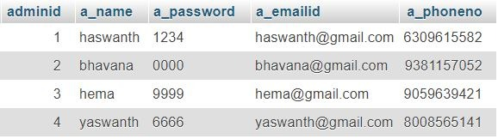

**Car details:**

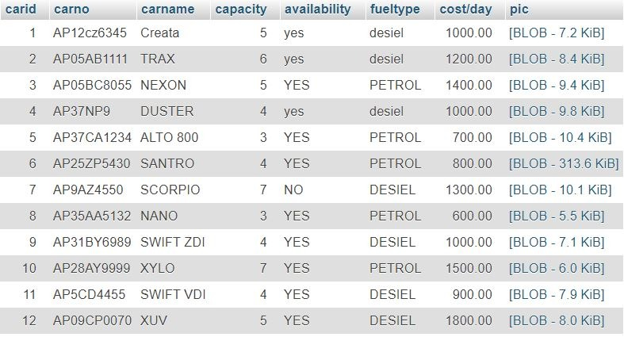

# Enquiry table:

# 

**Feedback Table:**

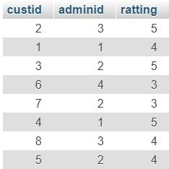

**User phoneno Table:**

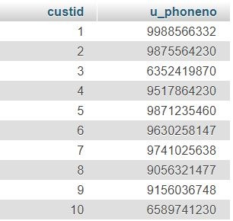

**Payment details Table:**

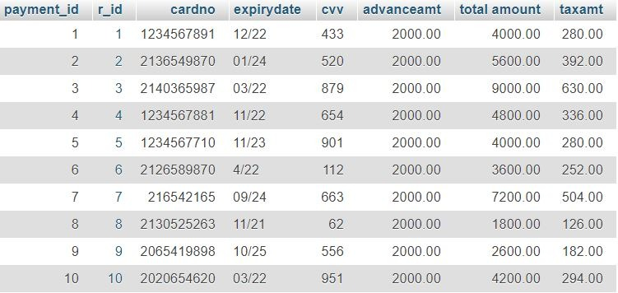

**Admin phoneno Table:**

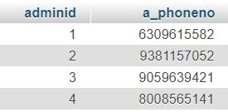

**Rent details Table:**

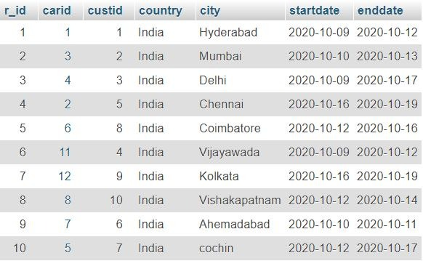

**User Table:**

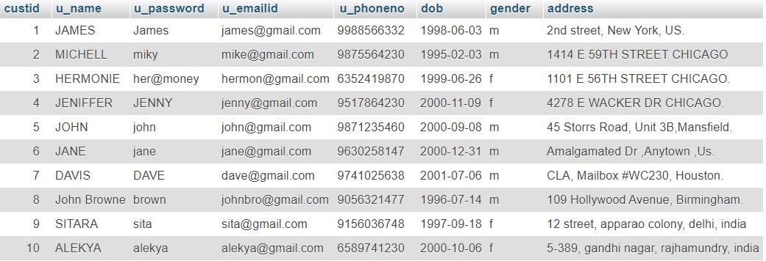

# Chapter 6 User Interface Design

**UI screens for data entry into all the tables.**

**Signup page:**

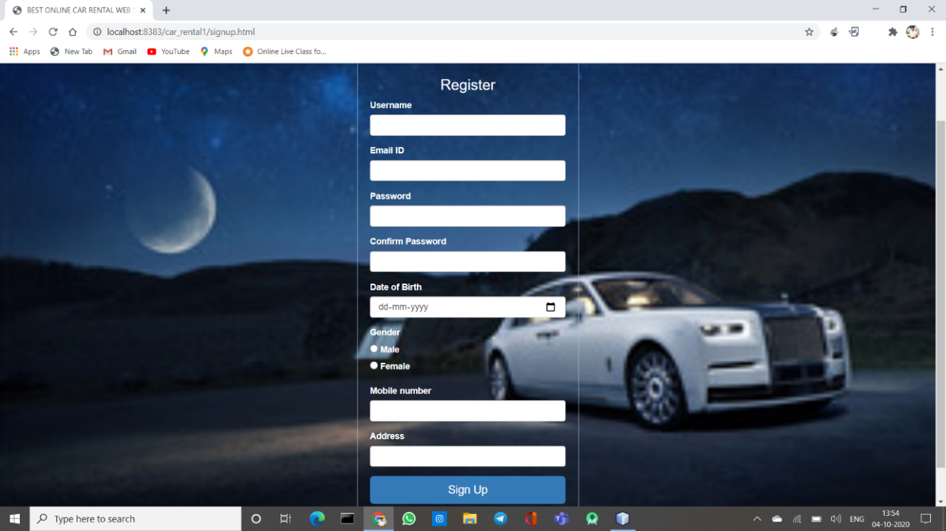

**Rent a car page:**

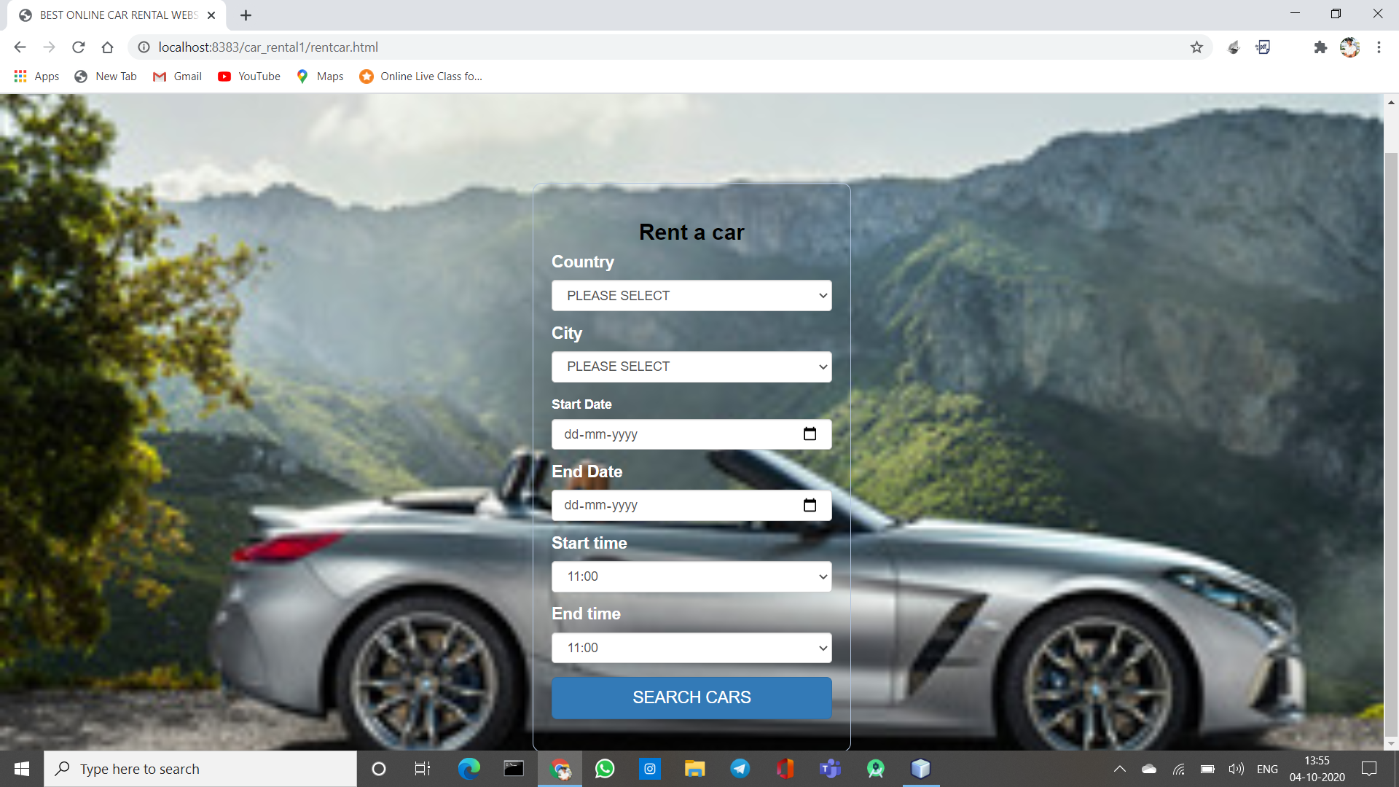

**Queries page:**

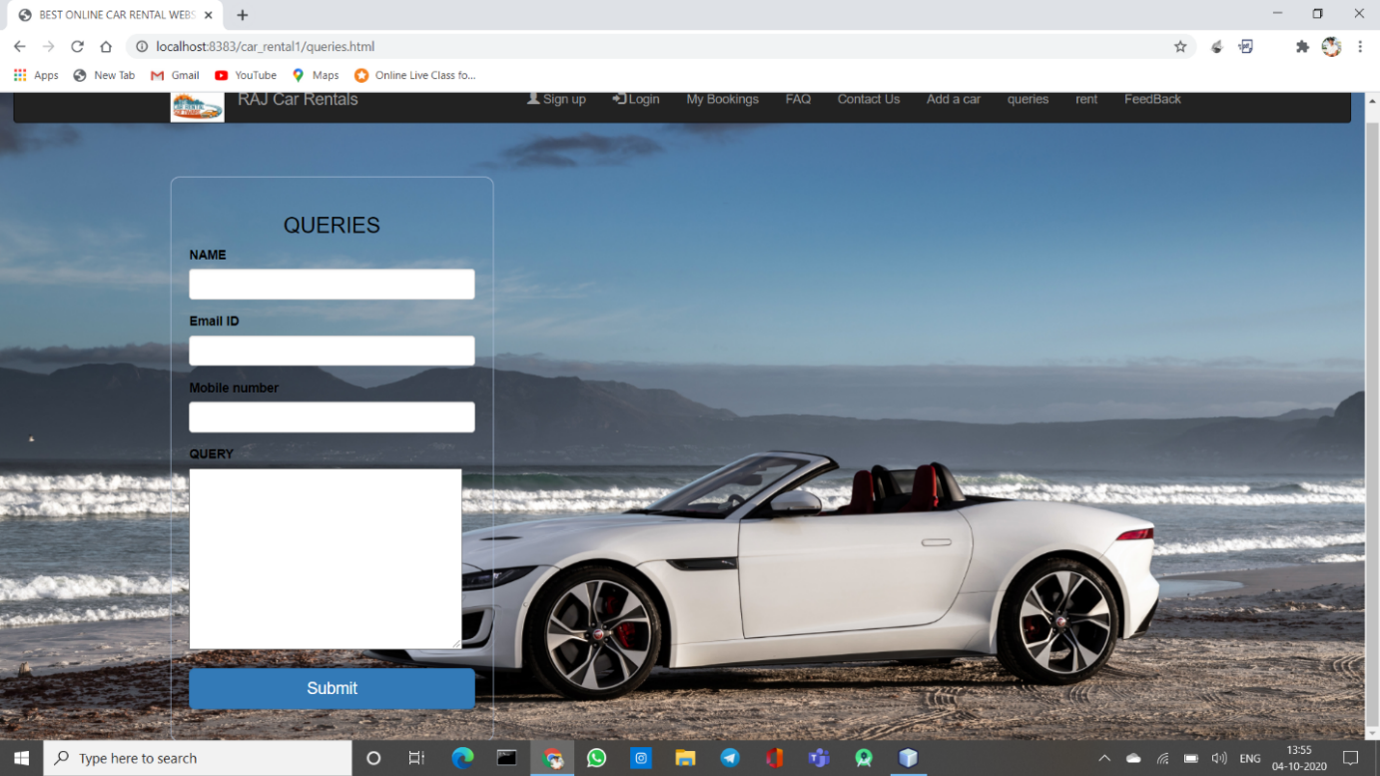

# Login page:

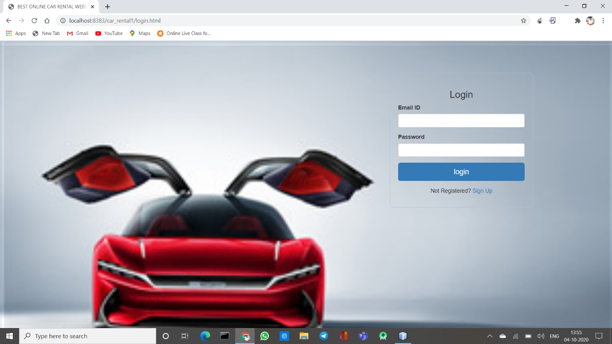

**Car details page:**

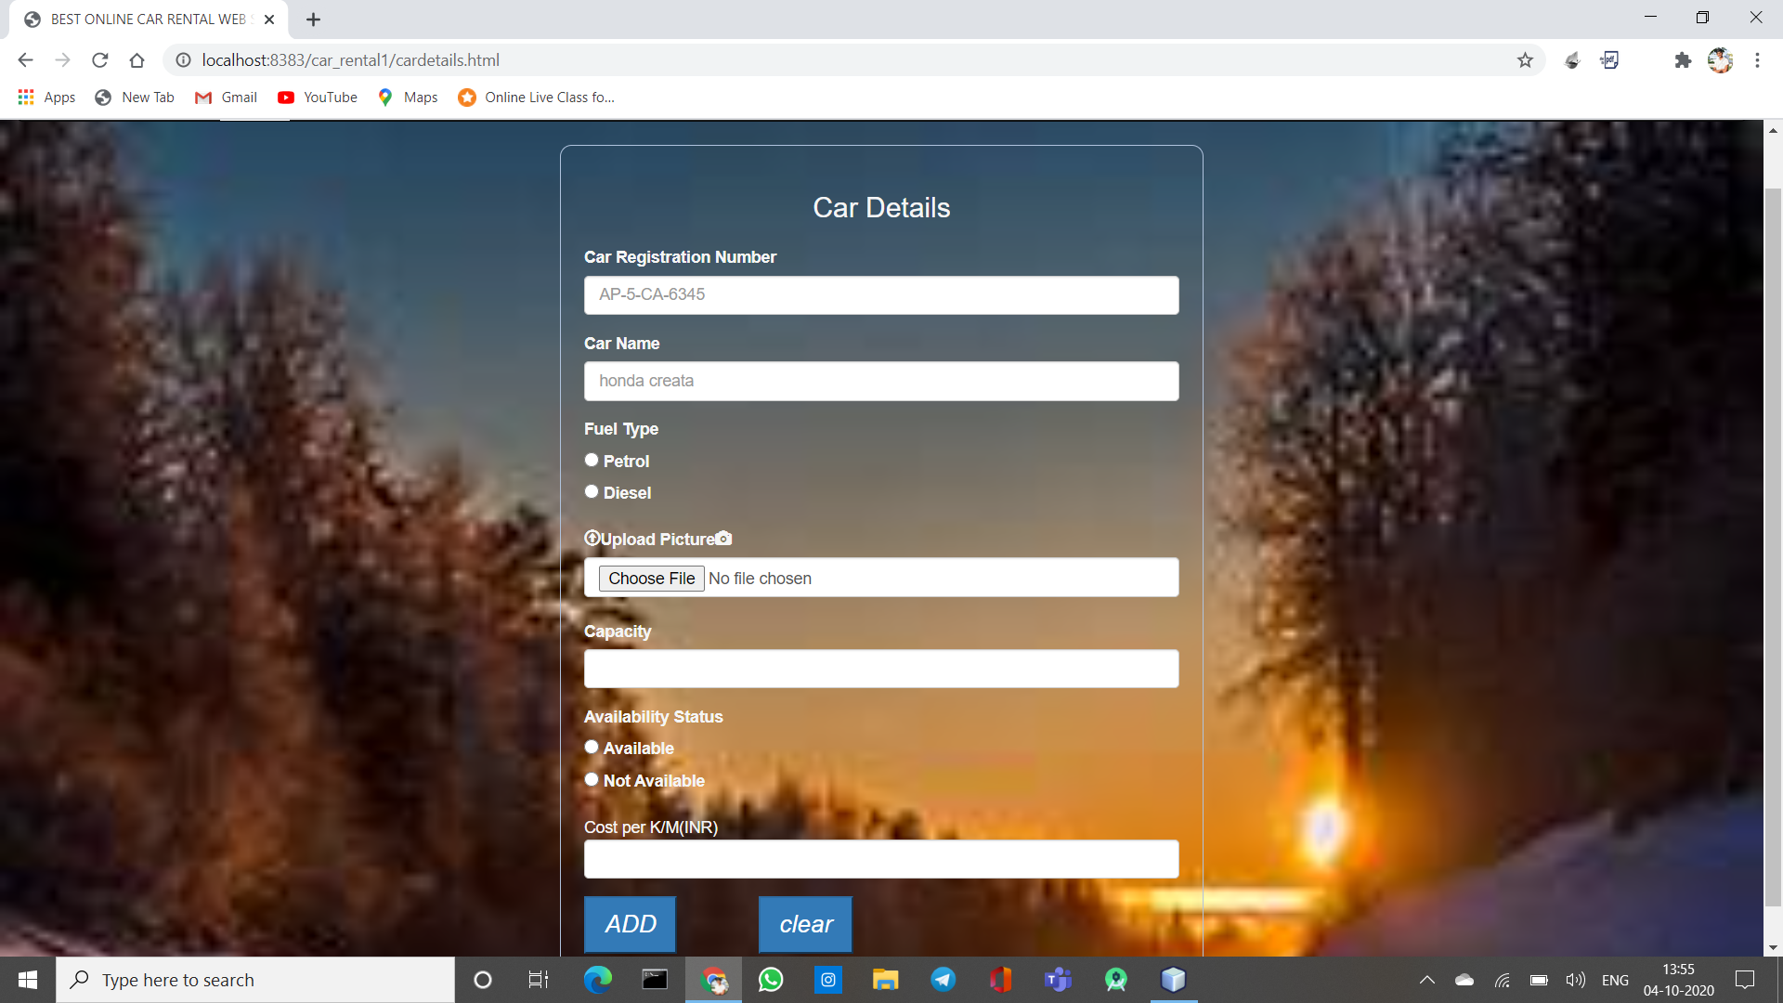

**Payment page:**

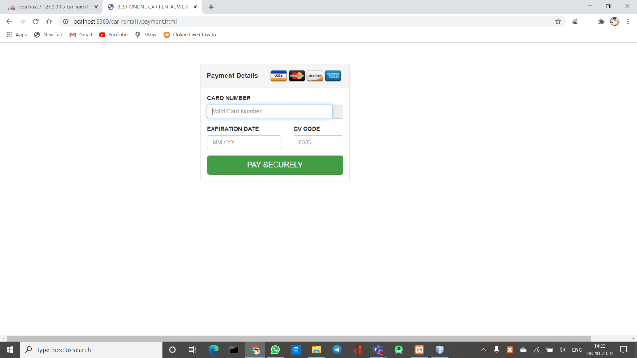

**Feedback page:**

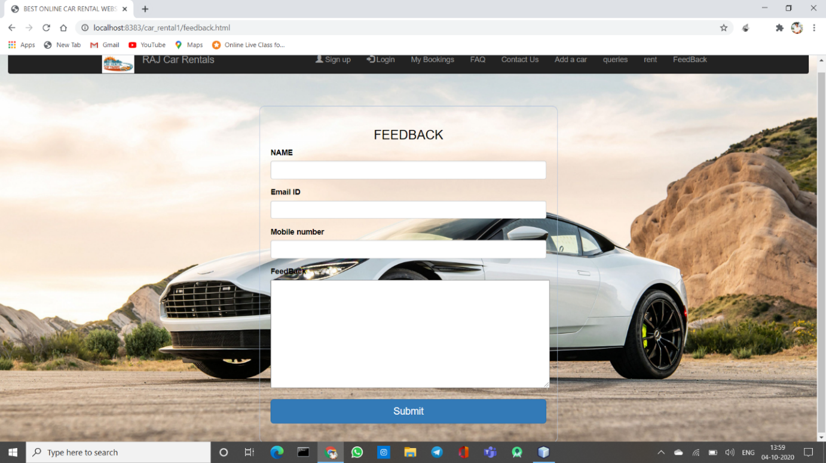

**Chapter 7: Connectivity Code**

**Connection:**

<?php

/*

* To change this license header, choose License Headers in Project Properties.

* To change this template file, choose Tools | Templates

* and open the template in the editor.

*/

$host = "localhost";

$user = "root";

$pass = "";

$db = "car_rental";

$con = mysqli_connect('localhost', 'root', '');

mysqli_select_db($con, 'car_rental');

if ($con->connect_error) {

die("$Connection failed: " . $con->connect_error);

}

**Signup:**

<?php

/*

* To change this license header, choose License Headers in Project Properties.

* To change this template file, choose Tools | Templates

* and open the template in the editor.

*/

session_start();

$con = mysqli_connect('localhost', 'root', '');

mysqli_select_db($con, 'car_rental');

if ($con->connect_error) {

die("$Connection failed: " . $con->connect_error);

}

$name = $_POST['username'];

$pass = $_POST['password'];

$email = $_POST['email'];

$dob = $_POST['dob'];

$gender = $_POST['gender'];

$address = $_POST['address'];

$phone = $_POST['phone'];

$sql1 = "select * from user where u_emailid='$email'";

$result = mysqli_query($con, $sql1);

$num = mysqli_num_rows($result);

$sql = "INSERT INTO user (u_name,u_password,u_emailid,u_phoneno,dob,gender,address) VALUES ('$name','$pass','$email','$phone','$dob','$gender','$address')";

if($num==0){

if(mysqli_query($con, $sql)){

$_SESSION['name']=$name;

header('location: /project/home1.php');

} else{

echo "not inserted". mysqli_error($con);

}

}else{

$message = "User Details of ". $email. " has already been inserted into the database";

echo "<script type='text/javascript'>alert('$message');</script>";

}

**Login:**

<?php

/*

* To change this license header, choose License Headers in Project Properties.

* To change this template file, choose Tools | Templates

* and open the template in the editor.

*/

session_start();

$con = mysqli_connect('localhost', 'root', '');

if(!$con)

{

echo"not connected to server";

}

mysqli_select_db($con, 'car_rental');

$pass = $_POST['password'];

$email = $_POST['email'];

$sql = "select * from user where u_emailid='$email' and u_password='$pass'";

$result = mysqli_query($con, $sql);

$num = mysqli_num_rows($result);

$sql2 = "select * from admin where a_emailid='$email' and a_password='$pass'";

$result2 = mysqli_query($con, $sql2);

$num1 = mysqli_num_rows($result2);

if($num == 1){

$_SESSION['email'] = $email;

echo '<script>alret("login successful")</script>';

header('location: /project/home1.php');

}elseif ($num1 == 1) {

header('location: /project/home2.php');

}else{

$message = "Username and/or Password incorrect.\\nTry again.";

echo "<script type='text/javascript'>alert('$message');</script>";

}

**Session:**

<?php

include('connection.php');

session_start();

$user_check=$_SESSION['email'];

$ses_sql=mysqli_query($con,"select u_name,custid from user where u_emailid='$user_check'");

$row=mysqli_fetch_array($ses_sql,MYSQLI_ASSOC);

$loggedin_session=$row['u_name'];

$loggedin_id=$row['custid'];

if(!isset($loggedin_session) || $loggedin_session==NULL) {

echo "Go back";

header("Location: index.php");

}

?>

**Home(Html Code):**

<?php

include('session.php');

?>

<!DOCTYPE html>

<!--

To change this license header, choose License Headers in Project Properties.

To change this template file, choose Tools | Templates

and open the template in the editor.

-->

<html>

<head>

<link rel="stylesheet" href="bootstrap-3.3.7-dist/css/bootstrap.min.css" type="text/css">

<link rel="stylesheet" href="https://maxcdn.bootstrapcdn.com/bootstrap/3.3.7/css/bootstrap.min.css" >

<script type="text/javascript" src="bootstrap-3.3.7-dist/js/jquery-3.4.1.min.js"></script>

<script type="text/javascript" src="bootstrap-3.3.7-dist/js/bootstrap.min.js"></script>

<title>BEST ONLINE CAR RENTAL WEBSITE</title>

<meta charset="UTF-8">

<meta name="viewport" content="width=device-width, initial-scale=1.0">

<link rel="stylesheet" type="text/css" href="style.css"/>

</head>

<body>

<div class="container-fluid">

<nav class="navbar navbar-inverse">

<div class="container">

<div class="navbar-header">

<button type="button" class="navbar-toggle" data-toggle="collapse" data-target="#mynavbar">

<span class="icon-bar"></span>

<span class="icon-bar"></span>

<span class="icon-bar"></span>

</button>

<a class="navbar-brand" href="home1.php"><img src="img/car_logo.jpg" class="logo" alt="car rental"></a>

<a href="home1.php" class="navbar-brand">RAJ Car Rentals</a>

</div>

<div class="collapse navbar-collapse" id="mynavbar">

<ul class="nav navbar-nav navbar-right">

<li><a href="my bookings.php">My Bookings</a></li>

<li><a href="contactus.php">Contact Us</a></li>

<li><a href="rentcar.php">rent</a></li>

<li><a href="faq.php">FAQ</a></li>

<li><a href="queries.php">queries</a></li>

<li><a href="feedback.php">FeedBack</a></li>

<li><a href="profile.php">Profile</a></li>

<li><a href="logout.php"><span class="glyphicon glyphicon-log-out"></span> LOGOUT</a></li>

</ul>

</div>

</div>

</nav>

</div>

<section>

<div>

<h3 style="margin:0;margin-bottom:5px;padding:15px;padding-bottom:10px;font-weight:700;font-size:16px;box-shadow:0 1px 4px rgba(255, 0, 0, 0.6);">Let's Find a Great Deal For Your Rental Car!</h3>

<h1 style="color: background;">Car Rental With Economy - Find and Book a Great Deal Today</h1>

<p>Enjoy the trip with fare prices.</p>

<h3>Welcome <?php echo $loggedin_session; ?></h3>

</div>

</section>

<div class="container-fluid">

<div class="row">

<div class="col-xs-12">

<img src="img/1stpage.jpg" class="img-responsive page-header" alt="responsive img" style="width: 100%;">

</div>

</div>

</div>

<div class="container">

<div class="row">

<div class="col-xs-5 bt-bottom-info" data-aos="fade-right">

<h2><strong>BEST online Car Rental Website</strong></h2>

</div>

<div class="col-xs-7 bt-bottom-info">

<h3 style="color: blue"><strong>ABOUT US</strong></h3>

<h4 style="text-align: justify;">we are new to online car rental portal.we are a group

of four members.We have started this online car rental

portal on the basis of our database management system.

We made easy to so many people who are struggling when

they are away to their home town or their vehicle

breakdown. They can rent a car online with best fares.</h4>

</div>

</div>

</div>

<section>

<h2><strong>Travel Gear</strong></h2>

<center>

<h4>We’re travelers, too, and want to know what works and what doesn’t before we hit </h4>

<h4>the road (or sky, or water, or rails). Our team tests the latest luggage, clothes, shoes, tech,</h4>

<h4>beauty products, camping gear, and more, so you can pack the right items for your</h4>

<h4>destination and travel style.</h4>

</center>

</section>

<section>

<div class="col-xs-12">

<div>

<h2><strong>Why book with us?</strong></h2>

<div>

<h3><b>Save More</b></h3>

<p>Our customers’ saving is far out. An amazing 35% average per booking! Monitoring the market on a daily basis guarantees value for money!</p>

<h3><b>Quality and Experience</b></h3>

<p>Customer service just a phone call away, available 365 days Trusted by millions of renters for over 30 years.</p>

<h3><b>Price Promise</b></h3>

<p>We are committed every day in finding the best possible solution for your car rental. Great prices supported by great service.</p>

</div>

<h4><b>No surprises at the desk!</b></h4>

</div><br><br>

</div>

<div class="col-xs-12" style="margin:0;margin-top:20px;padding:0 15px; background-color: whitesmoke">

<div class="row" style="padding-bottom:15px;">

<div class=col-md-3 style="color: black">

<h2><strong>Select it!</strong></h2>

<p><strong>Choose the perfect car for your needs from more than 6000 locations all over the world!</strong></p>

</div>

<div class=col-md-3 style="color: black">

<h2><strong>Book it!</strong></h2>

<p><strong>Book your car quickly and easily online. Select what you need and start planing your trip!</strong></p>

</div>

<div class=col-md-3 style="color: black">

<h2><strong>Collect it!</strong></h2>

<p><strong>Pick up the car at your destination. Fast and uncomplicated!</strong></p>

</div>

<div class=col-md-3 style="color: black">

<h2><strong>Drive it!</strong></h2>

<p><strong>Hit the road! The car will take you wherever you desire. Enjoy your trip and have a safe drive!</strong></p>

</div>

</div>

</div>

</section>

<footer>

<div>

<br><br>

<ul>

<li><strong><a href="rentcar.html">Rent a car</a></strong></li>

<li><strong><a href="#">About Us</a></strong></li>

<li><strong><a href="contactus.html">Contact Us</a></strong></li>

<li><strong><a href="#">My Bookings</a></strong></li>

<li><strong><a href="#">FAQ</a></strong></li>

<li><strong><a href="#">QUERIES</a></strong></li>

</ul>

<br><br>

</div>

</footer>

</body>

</html>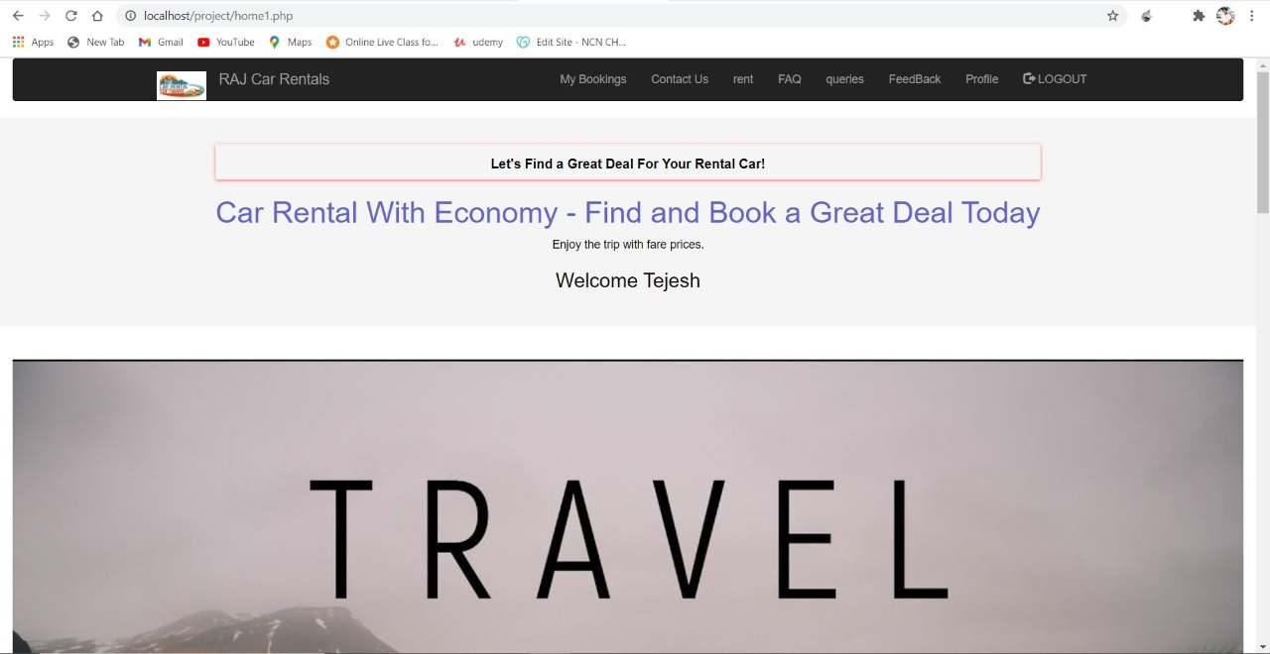

**Sign up (Html Code):**

<!DOCTYPE html>

<!--

To change this license header, choose License Headers in Project Properties.

To change this template file, choose Tools | Templates

and open the template in the editor.

-->

<html>

<head>

<link rel="stylesheet" href="bootstrap-3.3.7-dist/css/bootstrap.min.css" type="text/css">

<link rel="stylesheet" href="https://maxcdn.bootstrapcdn.com/bootstrap/3.3.7/css/bootstrap.min.css" >

<script type="text/javascript" src="bootstrap-3.3.7-dist/js/jquery-3.4.1.min.js"></script>

<script type="text/javascript" src="bootstrap-3.3.7-dist/js/bootstrap.min.js"></script>

<title>BEST ONLINE CAR RENTAL WEB SITE</title>

<meta charset="UTF-8">

<meta name="viewport" content="width=device-width, initial-scale=1.0">

<link rel="stylesheet" type="text/css" href="style.css"/>

</head>

<body style="background-image: url(https://www.hdnicewallpapers.com/Walls/Thumb/Rolls%20Royce/4K_Photo_of_2019_Rolls_Royce_Phantom_Tranquillity.jpg);background-repeat: no-repeat; background-size: cover">

<div class="container-fluid">

<nav class="navbar navbar-inverse">

<div class="container">

<div class="navbar-header">

<button type="button" class="navbar-toggle" data-toggle="collapse" data-target="#mynavbar">

<span class="icon-bar"></span>

<span class="icon-bar"></span>

<span class="icon-bar"></span>

</button>

<a class="navbar-brand" href="index.php"><img src="img/car_logo.jpg" class="logo" alt="car rental"></a>

<a href="index.php" class="navbar-brand">RAJ Car Rentals</a>

</div>

</div>

</nav>

</div>

<br><br>

<div class="container" style="color: white">

<div class="row">

<div class="col-xs-6 col-xs-offset-3">

<form action="reg.php" method="post" style="color: whitesmoke;">

<h3 class="text-center" style="margin-bottom: 20px;">Register</h3>

<div class="form-group">

<label for="username">Username</label><br>

<input type="text" name="username" class="form-control" required>

</div>

<div class="form-group">

<label for="password">Password</label><br>

<input type="password" name="password" class="form-control" required>

</div>

<div class="form-group">

<label for="email">Email ID</label><br>

<input type="email" name="email" class="form-control" required>

</div>

<div class="form-group">

<label for="dob">Date of Birth</label><br>

<input type="date" name="dob" class="form-control" required>

</div>

<div>

<label for="gender">Gender</label><br>

<input type="radio" id="male" name="gender" value="m">

<label for="contactChoice1">Male</label><br>

<input type="radio" id="female" name="gender" value="f">

<label for="contactChoice2">Female</label><br>

</div>

<div class="form-group">

<label for="address">Address</label><br>

<input type="text" name="address" class="form-control" required>

</div>

<div class="form-group">

<label for="phone">Mobile number</label><br>

<input type="number" name="phone" class="form-control" required>

</div> <br>

<div class="form-group">

<input type="submit" class="btn btn-primary btn-block btn-lg" value="Sign Up" />

</div>

<p class="text-center">Already a member? <a href="login.php">Sign In</a></p>

</form>

</div>

</div>

</div>

</body>

</html>

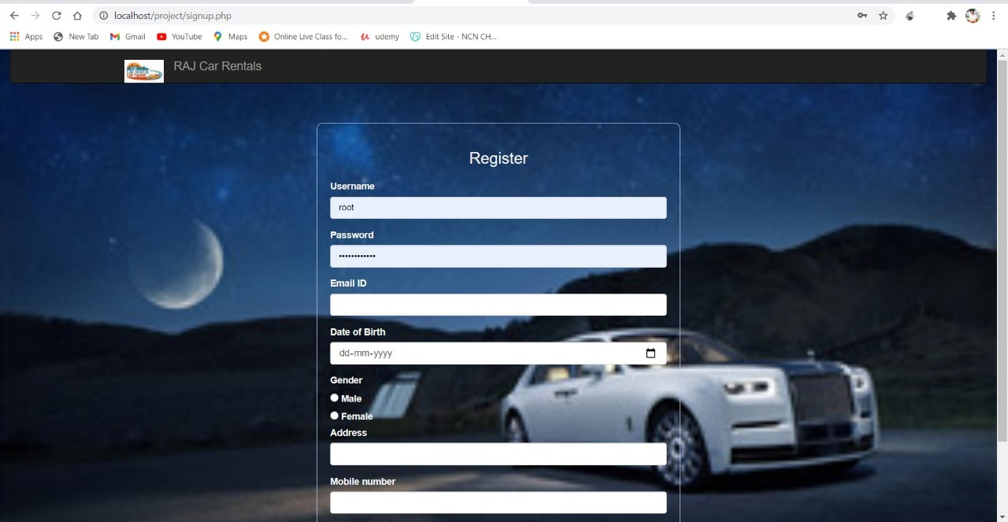

**References:**

<https://mucse44.net/wp-content/uploads/2019/09/Database-System-Concepts-7th-Edition.pdf>

Abraham Silberschatz , Henry F. Korth , S. Sudarshan Database System Concepts. 6th ed. New York: 1-December-2013